**An Android based Application for Automobile**

**By**

**NABEEL HASSAN CIIT/FA17-BCS-054/ATK**

**Supervised By**

**Mr. Yasir Ali Shah**

**Bachelor of Science in Computer Science (2017-2021)**

**The candidate confirms that the work submitted is their own and appropriate**

**credit and appropriate credit have been made to the work of others.**



**COMSATS University Islamabad, Pakistan**

**Android Application for Automobile**

**A project presented to**

**Comsats University Islamabad, Attock Campus**

**In partial fulfilment**

**of the requirement of the degree of**

**Bachelor of Science in Computer Science (2017-2021)**

**By**

**Nabeel Hassan CIIT/FA17-BCS-054/ATK**

**DECLARATION**

We hereby declare that this software, neither whole nor as a part has been copied out from any source. It is further declared that we have developed this software and accompanied the report entirely based on our efforts. If any part of this project is proved to be copied out from any source or found to be a reproduction of some other. We will stand by the consequences. No portion of the work presented has been submitted of any application for any other degree or qualification of this or any other university or institute of learning.

Nabeel Hassan

---------------------------

**CERTIFICATE OF APPROVAL**

It is to certify that the final year project of BS (CS) **“An Android Application for Automobile”** was developed by **Nabeel Hassan (CIIT/FA17-BCS-054/ATK)** under the supervision of **“Mr. Yasir Ali Shah”** and that in his opinion; it is fully adequate, in scope and quality for the degree of Bachelor of Science in Computer Sciences.

-------------------------------------------------------

**Supervisor**

-------------------------------------------------------

**External Examiner**

----------------------------------------------------

**Head of Department (Department of Computer Science)**

**Acknowledgment**

All praise is to Almighty Allah who bestowed upon us a minute portion of His boundless knowledge by virtue of which we were able to accomplish this challenging task.

We are greatly indebted to our project supervisor **“Mr. Yasir Ali Shah”**. Without his supervision, advice, and valuable guidance, completion of this project would have been doubtful. We are deeply indebted to them for their encouragement and continual help during this work.

And we are also thankful to our parents and family who have been a constant source of encouragement for us and brought us the values of honesty & hard work.

Nabeel Hassan

---------------------------

Contents

1 Introduction 8

1.1 Application Introduction: 8

1.2 Scope of the Project 9

2 **Literature Review………………………………………………………………………………**

2.1 Canadian Automobile Association 11

2.2 Automobile Association App 11

**3**  Requirement Specification………………………………………………………………….11

3.1 Sign up for new user 12

3.2 Forgot Password 12

3.3 Admin 12

4 Project design 13

4.1 Methodology 13

4.2 Design description 14

4.3 Use case diagram 14

4.4 Use cases 15

4.4.1 Start application 15

4.4.2 User Login 15

4.4.3 Search Service 16

4.4.4 Select Service 16

4.5 Admin use Case 17

4.5.1 Admin Select Service 17

4.5.2 Dialled numbers 17

4.5.3 Received numbers 18

4.6 Sequence diagrams 19

4.6.1 Register user 19

4.6.2 Login 20

4.6.3 Admin Login 21

4.6.4 Enter Service Provider Details 22

4.7 Activity diagrams 23

4.7.1 User Registration 23

4.7.2 Login user 24

4.7.3 Admin Login 25

**Chapter 1**

# Introduction

## Application Introduction:

## An Android application for Automobile is a smart android application that is used to provide basic services in automobile field. This application is a service provider application that provides services including Towing, Fuelling, Repairing, Lock smith and Battery Services. Similarly, user can contact whenever he needs a towing service to take the vehicle from one place to another in my case of emergency. This app saves the time of user by quickly providing them the selected service. Just like Towing service, all other services facilitate the user to overcome the daily issues by using our platform. This application provides services to the user at low and reasonable price as well as user can easily reach the destination. Our application has three modes: 1) Emergency service (Features: Taxi Towing, Repairing, Locksmith, Fuelling and Battery relevant Service.) 2) Normal service (Features: car washing, car tuning, car repairing) 3) Online shop (Features: Batteries change, Tyres change and Accessories) 4 An Android application for Automobile is a complete android-based platform and it will be accessible for everyone. There is no additional information required apart from mentioned ones and even in those required fields you must be precise. This platform is open for everybody; anyone can view the information on it but only the registered users can request the desired service. The administrator is controlling all operations using admin panel like approving the requests, adding the admin to take care of the system etc. If any request has any inappropriate information or any social norm is being broken than the administrator can delete the request.

Our application has three modes:

1) Emergency service (Features: Taxi Towing, Repairing, Locksmith, Fuelling and Battery relevant Service.)

2) Normal service (Features: car washing, car tuning, car repairing)

3) Online shop (Features: Batteries change, Tyres change and Accessories)

An Android application for Automobile is a complete android-based platform and it will be accessible for everyone. There is no additional information required apart from mentioned ones and even in those required fields you must be precise. This platform is open for everybody; anyone can view the information on it but only the registered users can request the desired service. The administrator is controlling all operations using admin panel like approving the requests, adding the admin to take care of the system etc. If any request has any inappropriate information or any social norm is being broken than the administrator can delete the request.

**Solution to the Problem**

It is very difficult to serve customers in short time if they are in emergency. A costumer needs a towing service to take the vehicle from one place to another in case of emergency. Just like Towing service, A costumer wants all other services like Fuelling, Repairing and Battery services etc in a very short period of and tries to save his time.

In Order to achieve this thing, the best solution is to provide the above service via mobile app and on the call. It is modern technique and Here the target marketplace have phone and Mobile Service is available then It is easy to achieve this.

## Scope of the Project

There are different modules used by the android application to get some certifiable result like all the service providers get registered by the admin itself and each task is assigned from the admin office. By using the Users and Service provider details get saved in the MySQL database which meets the requirements of authentication of service providers.

We are proposing to develop an android-based solution that will help the peoples to get an automobile service but now, they can save their time through this application. They will be able to get access to the platform on a single click. The aim of this project is to facilitate the community by modern ways.

1. Email and Password authentication.
2. Facebook and Instagram Login Authentication.
3. Resetting of the password in case of forgot the password.
4. Saving the user detail in the server.
5. Saving the Service provider details to the Server
6. Allows admin to Make a call to the service provider

**Chapter 2**

**Literature review**

In the current time frame, there are two famous web platforms which we found, that deal with this issue of our community. First platform is most famous one and it is an international organization called AAA (American Automobile Association). A second web platform is Canadian Automobile Association (CAA). In our country, there is no specific platform available which provide the reliable service related to Automobile Association.

**Motivation and Scope**

We are proposing to develop an android-based solution that will help the peoples to get an automobile service but now, they can save their time through this application. They will be able to get access to the platform on a single click. The aim of this project is to facilitate the community by modern ways.

## Automobile Association App

To design this portal, we have studied different websites of different countries that handled the different type of services. We have studied the mechanism of how they serve and work. We also asked a few people that how they would want the portal to be if they were using it. After analysing the mechanism and the layouts of different websites and keeping in mind the different suggestions given by the people, we got many ideas that how we can create our portal " An Android application for Automobile ".

Each day the app sends you a list of calls made, and texts exchanged from the phone. Access your text messages from your computer anytime, see a clean log of text messages, calls with the time they were sent / received with the names from the phone contact list too. Configure the app to get all your text messages in your mail daily or weekly. Access to all your text and SMS messages at all time via your email. Access to your call logs so you know who you called at what time.

**Canadian Automobile Association**

The Canadian Automobile Association commonly known as (CAA) is a non-profit federation, founded in 1913, of eight motor clubs across Canada, providing roadside assistance service, insurance services, and member discount. 5 2.3 Automobile Association App To design this portal, we have studied different websites of different countries that handled the different type of services. We have studied the mechanism of how they serve and work. We also asked a few people that how they would want the portal to be if they were using it. After analysing the mechanism and the layouts of different websites and keeping in mind the different suggestions given by the people, we got many ideas that how we can create our portal " An Android application for Automobile ".

**Chapter 3**

**Requirements specification**

### 

### Sign up for new user

The costumers get registered with the database with their name, email, and the password. All this work is done in the MySQL database using Internet Service. If the internet service is not available, then the user cannot save his/ her with the application database.

**Login an Existing User**

The registered user can login and when a user get login it matches with the existing user. If the user is already registered the user will be able to login. If the user is not already registered, then it shows that register with the application first.

**User Login Afterward**

After User Login, it shows the Interface where the User can select the required car Maintenance service and Make a phone call to the admin and then the admin assigns the task to the mechanic.

### Forgot Password

If a user forgets his password a page is available in the application, the user put its email address then the reset password will be sent to his email address provided by the user.

### Admin

1. Administrator can add mechanics.
2. Administrator can add services.
3. Administrator can update services.
4. Administrator can delete mechanics/Service.

**Admins login**

Admins can login after he\she registered his\her name, email address, email password and phone number. The Admin Can Register new users/mechanics and their service also. All the work is done using the MySQL Database

**Chapter 4**

**Project design**

# Project design

## Methodology

We have chosen Mobile Application Development Lifecycle (MADLC) as we are developing mobile application and Mobile Application Development Lifecycle provides us phases for development. We used android studio for developing this application. It is a dedicated framework lifecycle for mobile. The proposed lifecycle includes the following phases: Identification, Design, Development, Prototyping, Testing and Maintenance. This lifecycle has been used for over a year in developing Android mobile applications. This lifecycle addresses some of the distinguishing characteristics of mobile applications like life span, complex functionalities, fewer physical interfaces, a greater number of screens for interaction, battery and memory usage, cross platform development and maintenance.

**Mobile Application Development Lifecycle Model (MADLC**)

As the mobile applications have complex functionality and are different from the desktop applications, the following Mobile Application Development Lifecycle model (MADLC) is proposed to enable a systematic approach in development.

## Design description

Following are the modules constituting the product to be developed.

Following are some diagrams of our module including.

* Use case diagram
* Sequence diagram
* Activity diagram

## Use case diagram

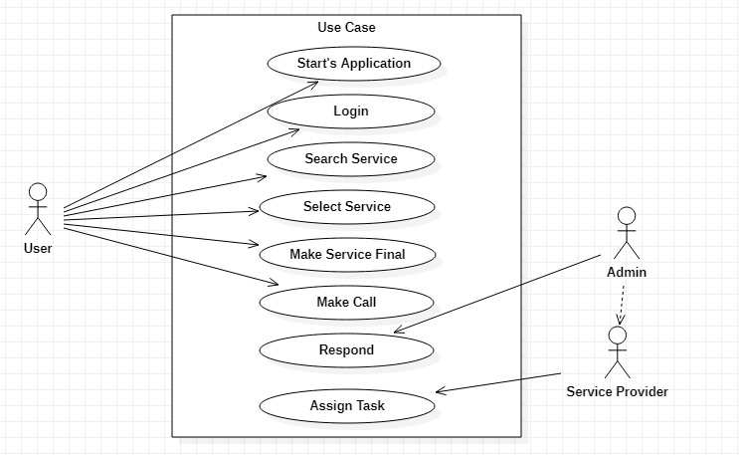

(Fig 4.1) System Use Case Diagram

**Description**

In figure 4.1 the user get login and select login and search for the service. When the user selects the required service and make a call to admin. The admin picks up the call and give the task to the service provider. Then the Service provider entertain the User with the service.

## Use cases

### Start application

|  |  |
| --- | --- |
| **UC id:** | 1 |
| **Use case name:** | Start application |
| **Actor name:** | User |
| **Pre-condition:** | Users have android phone, and he must install application |
| **Post-condition:** | The App get Started |

### User Login

|  |  |
| --- | --- |
| **UC id:** | 2 |
| **Use case name:** | Login |
| **Actor name:** | User |
| **Pre-condition:** | User can login into system with id and password |
| **Post-condition:** | User will login into system |

### Search Service

|  |  |
| --- | --- |
| **UC id:** | 4 |
| **Use case name:** | Search Service Provider |
| **Actor name:** | User |
| **Pre-condition:** | Users get Login |
| **Post-condition:** | User Search for Service |

### Select Service

|  |  |
| --- | --- |
| **UC id:** | 5 |
| **Use case name:** | Select Service |
| **Actor name:** | User |
| **Pre-condition:** | User Searched Service |
| **Post-condition:** | Select Service and make Call to Admin |

## Admin use Case

### Admin Select Service

|  |  |
| --- | --- |
| **UC id:** | 6 |
| **Use case name:** | Admin Login |
| **Actor name:** | Admin |
| **Pre-condition:** | Admin Have Installed application |
| **Post-condition:** | Admins get login into app. |

### Dialled numbers

|  |  |
| --- | --- |
| **UC id:** | 7 |
| **Use case name:** | Register Service Providers |
| **Actor name:** | Admin |
| **Pre-condition:** | Admin already login |
| **Post-condition:** | Admin Register the Service Providers |

### Received numbers

|  |  |
| --- | --- |
| **UC id:** | 8 |
| **Use case name:** | Assign task |
| **Actor name:** | Admin |
| **Pre-condition:** | Admin Already Login |
| **Post-condition:** | Assign task to the Service provider |

## Sequence diagrams

### Register user

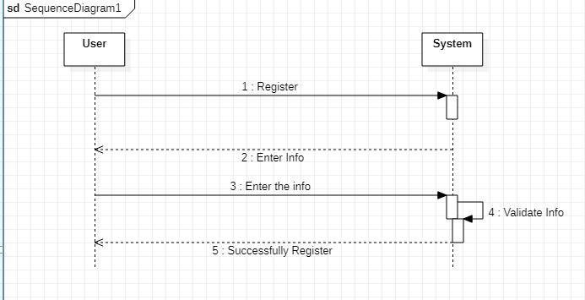

(Fig 4.2) Sequence diagram of Registration

**Description**

A sequence diagram is an interaction diagram that show how object operate with one another and in what order. In figure 4.2 sequence diagram of register user. In this user register with their name email, phone no and password.

### Login

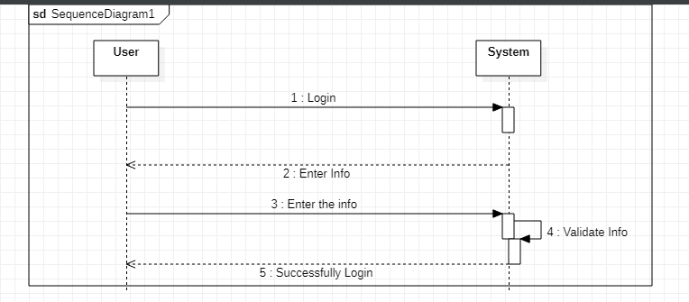

(Fig 4.1) Sequence diagram of login

**Description**

In figure 3 there are 3 lifelines including user login. Users enter email and password, then successfully get login Int System.

### Admin Login

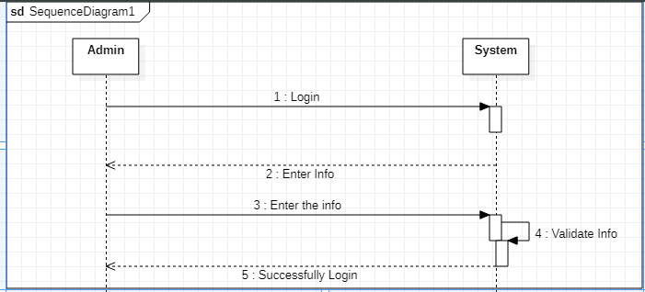

(Figure 4.2) Sequence diagram of Admin Login

**Description**

In figure 3 there are 3 lifelines including user login. Users enter email and password, then successfully get login Into System.

### Enter Service Provider Details

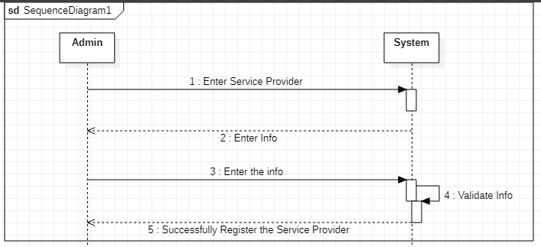

(Fig 4.2) Sequence diagram of Service Provider Registration

**Description**

In figure 4.5 there are 3 lifelines including Admin, device, and database. When Admin logging into system the service providers details will be saved by the admin into system.

## Activity diagrams

### User Registration

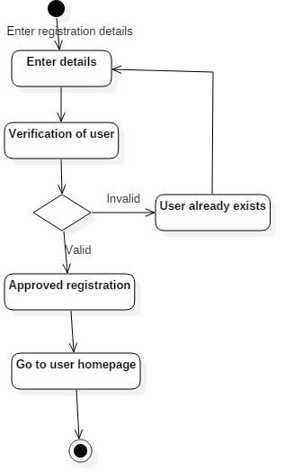

(Fig 4.3) Activity diagram of register user

**Description**

In figure 4.6 users register with the system. Users enter their name and password than system verifies user account if user already exists than go back to enter details. If user not already exists than its registration is approved, and homepage is open.

### Login user

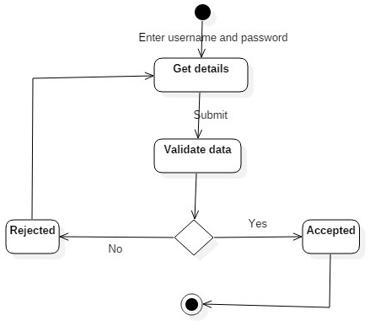

(Fig 4.4) Activity diagram of login use

**Description**

In figure 7 user enter their name and password, if the password is correct than user logging into system, if name or password is incorrect than user again enter name or password.

### Admin Login



(Fig 4.5) Activity diagram of Admin Login

**Description**

In figure 4.6 user enter their name and password, if the password is correct than user logging into system, if name or password is incorrect than user again enter name or password.